A TECHNICAL REPORT ON STUDENT INDUSTRIAL WORK EXPERIENCE SCHEME

(SIWES) TRAINING PROGRAMME

(APRIL 2024-SEPTEMBER 2024)

UNDERTAKEN AT



NIGERIAN AIRSPACE MANAGEMENT AGENCY

(NAMA)

Murtala Muhammed International Airport

P.M.B. 21084, Ikeja, Lagos.

Email: [info@namahqtr.net](mailto:info@namahqtr.net)

BY

OLOJA JOSEPH OLUWATOMISIN

20/ENG02/047

DEPARTMENT OF COMPUTER ENGINEERING

FACULTY OF ENGINEERING

AFE BABALOLA UNIVERSITY

BEING A REPORT SUBMITTED TO THE FACULTY OF ENGINEERING IN PARTIAL FULFILMENT OF THE REQUIREMENTS FOR B.ENG DECREE PROGRAMME

OCTOBER 2024

# CERTIFICATION

This is to certify that the STUDENTS’ INDUSTRIAL WORK EXPERIENCE SCHEME (SIWES) was carried out by OLOJA JOSEPH OLUWATOMISIN with student matriculation number 20/ENG02/047 at Nigerian airspace management agency and the report submitted to the Department of Computer Engineering, College of Engineering, Afe Babalola University, Ado-Ekiti, Nigeria, in partial fulfilment of the requirements for the award of Bachelor of Engineering (B.Eng.) Degree in Computer Engineering.

|  |  |
| --- | --- |
| __________________________  DR. M. A. OGUNLADE  SIWES Coordinator | __________________________  DATE |
| __________________________  SIWES Supervisor  Engr. Dr. Aderonke Akinwumi | __________________________  DATE |
| __________________________  ENGR. DR. FEMI ONIBONOJE  HOD | __________________________  DATE |

# DEDICATION

This report is dedicate to the Almighty God for granting me the opportunity and strength to successfully complete this internship. I also dedicate it to my family, especially my parents, Mr. and Mrs. Oloja, for their unwavering support and for providing all the resources I needed. Additionally, I dedicate this to my friends and colleagues at the Nigerian Airspace Management Agency (NAMA), whose collaboration and camaraderie made this journey even more fulfilling.

# ACKNOWLEDGEMENT

I wish to express my sincere appreciation to God almighty for the guidance and grace throughout my life, the period I used for my Industrial Training and for giving me the grace to have a well-established organization as my IT placement.

I am grateful to the entire staff of NIGERIAN AIRSPACE MANAGEMENT AGENCY (NAMA) for the chance to learn professional development, and for making my Industrial Training educative and worthwhile. My special gratitude to the General Manager (GM) of my department Mrs. S.A Onusi and the Heads of all the different sections in my department. Mr. Achinivu Nkem (Head of ITSM), Mr. Femi (Head of BOS), Mr. Patrick (Head of BIS), Mr. E.A Adeniran and (Head of NETCOMMS) and Mrs. Rammat (Head of Reprographic) and to all my supervisors of ICT Mr. Taofeek, Mr. Tobi, Mr. Yemi, Mr. Ibrahim and Mrs. Farida for all their effort to see this work sae the light of the day. For all their hard work and dedication towards me during my IT period.

And my regards to my parent Mr. & Mrs. Oloja who financially supported my SIWES and educational pursuit. I want to say thank you and may the almighty God bless you.

I also would like to thank the management and staff of Afe Babalola University with special regards to Faculty of Engineering and department of Computer Engineering for subscribing to this platform of learning and encouraging participation.

# ABSTRACT

In this technical report, I go over everything I learned while participating in the Students Industrial Work Experience Scheme (SIWES) at the Nigerian Airspace Management Agency (NAMA), in Ikeja, Lagos state, from April 2024 to September 2024. This report accurately describes all the previously discussed subject matter and outlines the acquired experience. It also highlights some problems I encountered during the process of acquiring this experience and a few solutions that I believe will help improve the purpose of the program.

Chapter one deals with the concept of SIWES. This chapter contains the history of SIWES, coordinators of SIWES, Statistical data of SIWES as regard schools undertaking the scheme and finally the aims and objectives of SIWES. Chapter two deals with NAMA which is the company where the training was done. The company’s history, Goals, Achievement and nature of work done by the company and relevance to trainee’s field of study is discussed in this chapter. Chapter three deals with the activities carried out during the period of attachment. Chapter four deals with the experiences gained and challenges faced by trainee while undertaking the SIWES training program. Some recommendation to surmount these challenges are also discussed in this chapter and a conclusion which summarizes the whole chapters from chapter one to five is done.

Table of Contents

CERTIFICATION ii

DEDICATION iii

ACKNOWLEDGEMENT iv

ABSTRACT v

CHAPTER 1 1

**1.0 INTRODUCTION** 1

1.1 SIWES 1

1.2 HISTORY OF SIWES 1

1.3 Objectives of SIWES 2

1.4 INTRODUCTION TO NIGERIAN AIRSPACE MANAGEMENT AGENCY 3

1.4 ACHIEVEMENT 3

CHAPTER 2 5

2.1 Nigerian Airspace Management Agency (NAMA) 5

2.2 NAMA’s Vision 6

2.3 NAMA’s Mission: 6

2.4 Size And Type Of Organization 6

2.5 Functions of the organization include 6

2.6 The Organizational Structure of NAMA 7

2.5 ICT DEPARTMENT IN NIGERIAN AIRSPACE MANAGEMENT AGENCY 9

2.6 ICT VISION 9

2.7 ICT MISSION 9

2.8 VARIOUS ICT DEPARTMENT AT NIGERIAN AIRSPACE MANAGEMENT AGENCY 9

2.9 Training Centre 11

CHAPTER 3 12

**3.0 DESCRIPTION OF WORK DONE** 12

3.1.2 Network Communications (Netcomms) 12

3.1.3 Business Operations Support (BOS) 13

3.1.4 Business Intelligence System (BIS) 14

3.1.5 Training Centre 15

3.10.5 PYTHON 26

**3.10.6 CSS (Cascading Style sheet)** 33

**3.10.7 JAVASCRIPT** 35

CHAPTER 4 38

CHALLENGES AND RECOMMENDATION 38

4.1 CHALLENGES 38

4.2 RECOMMENDATIONS 38

4.3 OBSERVATIONS AND CONTRIBUTIONS 38

4.4 RELEVANCE OF EXPERIENCE/KNOWLEDGE GAINED 39

CHAPTER 5 39

CONCLUSION 39

5.0 CONCLUSION 39

REFERENCES 40

Table of Figures

Figure 1organizational structure of NAMA 8

Figure 2 helpdesk interface 1 11

Figure 3 helpdesk interfacee 2 14

Figure 4 A typical diagram of a computer HDD hard drive 26

Figure 5 different types of ethernet connectors 27

Figure 6A Hub connection 28

Figure 7 vlan connection 28

Figure 8 anetwork adaptor 29

Figure 9 ethernet cable 30

Figure 10 server 33

Figure 11 server extension 33

# CHAPTER 1

# **1.0 INTRODUCTION**

## 1.1 SIWES

SIWES, which is similar to the SIWES scheme was established by the Federal Government to solve the problem of lack of practical skills preparatory for employment in industries by Nigerian graduates of tertiary institutions.

The scheme exists to expose 400 level students to industry-based skills necessary for a smooth transition from the classroom to the world of work. It affords students of tertiary institution the opportunity of being exposed to the necessary experience in handling machinery and equipment, which may not be available in the educational institutions.

The Students Industrial Work Experience Scheme (SIWES) is the accepted training programme, which is part of the approved Minimum Academic Standard in the various degree programmes for all Nigerian Universities. The scheme is aimed at bridging the existing gap between theory and practice of Sciences, Agriculture, Medical Sciences (including Nursing), Engineering and Technology, Management, Information and Communication Technology, and other professional educational programs in the Nigerian tertiary institutions

## 1.2 HISTORY OF SIWES

SIWES was established by ITF in 1973 to solve the problem of lack of adequate practical skills preparatory for employment in industries by Nigerian graduates of tertiary institutions. The Scheme exposes students to industry based skills necessary for a smooth transition from the classroom to the world of work. It affords students of tertiary institutions the opportunity of being familiarized and exposed to the needed experience in handling machinery and equipment which are usually not available in the educational institutions.

Participation in Industrial Training is a well-known educational strategy. Classroom studies are integrated with learning through hands-on work experiences in a field related to the student s academic major and career goals Successful internships foster an experiential learning process that not only promotes career preparation but provides opportunities for learners to develop skills necessary to become leaders in their chosen professions.

One of the primary goals of the SIWES is to help students integrate leadership development into the experiential learning process. Students are expected to learn and develop basic non-profit leadership skills through a mentoring relationship with innovative non-profit leaders. By integrating leadership development activities into the Industrial Training experience, we hope to encourage students to actively engage in non-profit management as a professional career objective.

However, the effectiveness of the SIWES experience will have varying outcomes based upon the individual student, the work assignment, and the supervisor/mentor requirements. It is vital that each internship position description includes specific written learning objectives to ensure leadership skill development is incorporated. Participation in SIWES has become a necessary pre-condition for the award of Diploma and Degree certificates in specific disciplines in most institutions of higher learning in the country, in accordance with the education policy of government.

## 1.3 Objectives of SIWES

The ITF, the coordinating agencies (NUC, NCCE, NBTE), employers of labor and the institutions. Funding - The Federal Government of Nigeria Beneficiaries - Undergraduate students of the following: Agriculture, Engineering, Technology, Environmental, Science, Education, Medical Science and Pure and Applied Sciences. Duration - Four months for Polytechnics and Colleges of Education, and Six months for the Universities.

The following are some of the objectives of SIWES:

1. SIWES will provide students the opportunity to test their interest in a particular career before permanent commitments are made.

2. SIWES students will develop skills in the application of theory to practical work situations.

3. SIWES will provide students the opportunity to test their aptitude for a particular career before permanent commitments are made.

4. SIWES students will develop skills and techniques directly applicable to their careers.

5. SIWES will aid students in adjusting from college to full-time employment.

6. SIWES will provide students the opportunity to develop attitudes conducive to effective interpersonal relationships.

7. SIWES will increase a student's sense of responsibility.

8. SIWES students will be prepared to enter into full-time employment in their area of specialization upon graduation.

9. SIWES students will acquire good work habits.

10. SIWES students will develop employment records/references that will enhance employment opportunities.

11. SIWES will provide students the opportunity to understand informal organizational interrelationships.

12. SIWES will reduce student dropouts.

13. SIWES Students will be able to outline at least five specific goals with several staff members by comparing performance with job duties and develop a draft plan with staff to accomplish performance needs, supervision plan and rewards.

14. SIWES Students will be able to develop a draft agency or project budget and will be able to identify methods of obtaining revenue to support the budget.

15. SIWES Students will be able to provide tools to use in prioritizing tasks of an assigned project and create with staff a tentative schedule for completion based on these tasks.

## 1.4 INTRODUCTION TO NIGERIAN AIRSPACE MANAGEMENT AGENCY

The Nigerian Airspace Management Agency (NAMA) is a government agency responsible for providing safe, efficient, and effective air navigation services in Nigeria's airspace. Established in 1999, NAMA operates under the Nigerian Ministry of Aviation and ensures that the country's airspace is managed in compliance with international standards. Its key functions include air traffic control, airspace planning, navigation aids management, and ensuring the safety of aircraft operations. NAMA also plays a crucial role in modernizing Nigeria's air traffic infrastructure through the use of advanced technologies, contributing to the overall development of the aviation industry in the country.

## 1.4 ACHIEVEMENT

* **Implementation of Total Radar Coverage of Nigeria (TRACON):** NAMA established the TRACON project, which provides full radar coverage across Nigeria's airspace, enhancing air traffic control and improving safety.
* **Successful Transition to Performance-Based Navigation (PBN):** NAMA implemented PBN, allowing aircraft to navigate using satellite-based systems, which improved the efficiency and safety of flight operations.
* **Upgrading of Navigational Aids:** The agency modernized various navigational aids, including Instrument Landing Systems (ILS) and Very High Frequency Omni-Directional Range (VOR) systems, at key airports across Nigeria.
* **Deployment of Aeronautical Information Services (AIS) Automation:** NAMA automated the provision of aeronautical information, improving the accuracy and speed of information dissemination to pilots and airlines.
* **Capacity Building and Training:** NAMA consistently invests in the training and retraining of its personnel, ensuring that staff are equipped with the latest skills and knowledge for managing air traffic efficiently.
* **Air Traffic Management System Upgrade:** The agency upgraded its Air Traffic Management (ATM) systems to enhance communication, navigation, and surveillance, leading to improved airspace safety and efficiency.
* **Establishment of Satellite-Based Communication Systems:** NAMA installed satellite-based communication systems that enhance real-time communication between pilots and air traffic controllers, especially in remote areas.
* **Continuous Safety Audits and Certification:** NAMA regularly passes International Civil Aviation Organization (ICAO) audits, maintaining compliance with international aviation safety standards.

# CHAPTER 2

### 2.1 Nigerian Airspace Management Agency (NAMA)

The headquarters of the Nigerian Airspace Management Agency (NAMA) is located opposite the Ikeja Domestic Terminal of Murtala Mohammed Airport, Lagos State, and has branches at various airports in the country. Its headquarters formerly at Lagos, is now located at Abuja.

**BRIEF HISTORY OF NAMA**: On August 31, 1995, the Federal Government announced the reorganization of the aviation industry, combining the former Nigerian Airport Authority (NAA) and the Federal Civil Aviation Authority (FCAA) into a new organization called the Federal Airport Authority of Nigeria (FAAN) passed decree No. 9 of 1996.

With effect on January 1, 2000 and carried out another reorganization; the FAAN was dissolved and the Federal Airport Authority Of Nigeria (FAAN), the Nigerian Airspace Management Authority (NAMA) and Nigerian Civil Aviation Authority (NCAA). Former FCAA employees and their functions have been transferred to NAMA, and they have now become their own organization by Decree No. 48 of 1999. The organization began operations on January 1 of 2000.

NAMA is responsible for ensuring the safety of aircraft in Nigerian airspace and for providing security facilities for the take-off and landing of any aircraft. These facilities include Distance Measuring Equipment (DME), Instrument Landing System (ILS), Non-directional Beacon (NDB), Very High Omnidirectional Radio Range (VOR), Radio Directing and Ranging (RADAR), etc. These facilities must be provided in accordance with the International Standards and Recommended Practices (ISARP) stipulated by the International Civil Aviation Organization (ICAO).

2.2 NAMA’s Vision*:*

*To be one of the leading Air Navigation Service Providers (ANSP) in the world.*

### 2.3 NAMA’s Mission:

*Provision of safe, efficient, effective, and economic air navigation services.*

### 2.4 Size And Type Of Organization

The Nigerian Airspace Management Agency branch at Ikeja, Lagos, comprises of roughly 400-600 employees and is a government owned company.

### 2.5 Functions of the organization include

* To provide safe and functional air traffic services that will meet international standards.
* To increase air traffic control (ATC) capacities in order to manage increasing air traffic volumes and at the same time reduce delays.
* To provide ATC services in the country, including visual and non-visual aids, aeronautical telecommunication services, to enable public transportation, private business and military aircraft fly as far as practicable and safe as possible.
* Ensure an effective co-ordination in the use of the Nigerian airspace in line with established standards and procedures.
* Provision of adequate facilities and personnel for efficient airspace management services and effective security of navigational aids outside the airport parameters.
* Installation and effective maintenance of air navigational facilities in all the airports and air routes.
* Restructuring of the routes for positive area airways control.
* Provision of total radar coverage for Nigeria s airspace.
* Liaise with international organizations for improvement of air navigation services.
* To hold meetings with the Armed Forces on Nigeria s international obligation as they relate to civil and military co-ordination.

### 2.6 The Organizational Structure of NAMA

The Organizational structure of NAMA has the Federal Ministry of Transport, State Ministry for Air Transport as its supervisory body, to whom the Board is responsible. The Managing Director is a member of the board and he reports to the board. The structure of the organization is in a form where there are 22 Airports in the country and each airport is headed by an Airspace Manager who is responsible to the Managing Director. Each Airport has its staff responsible to the Airspace Manager. There are seven (7) Directorates with the Executive Directors responsible to the Managing Director.

These Directorates of the organization are:

1. Directorate of Human Resources (DHR)
2. Directorate of Finance (DOF)
3. Directorate of Air Traffic Services (DATS)
4. Directorate of Safety Electronics Services (DSES)
5. Directorate of Corporate Affairs/Legal Services (DCALS)
6. Directorate of Aeronautical Information (DAIS)
7. Directorate of Commercial and Business Development (DCBD) Other service departments are:

* Audit
* Information and Communication Technology (ICT)
* Quality Assurance and Safety Management
* Planning/Project Management, which are directly under the supervision of the Managing Director.

The pictorial representation of the Nigerian Airspace Management Agency (NAMA) is sighted in the

Figure 1organizational structure of NAMA

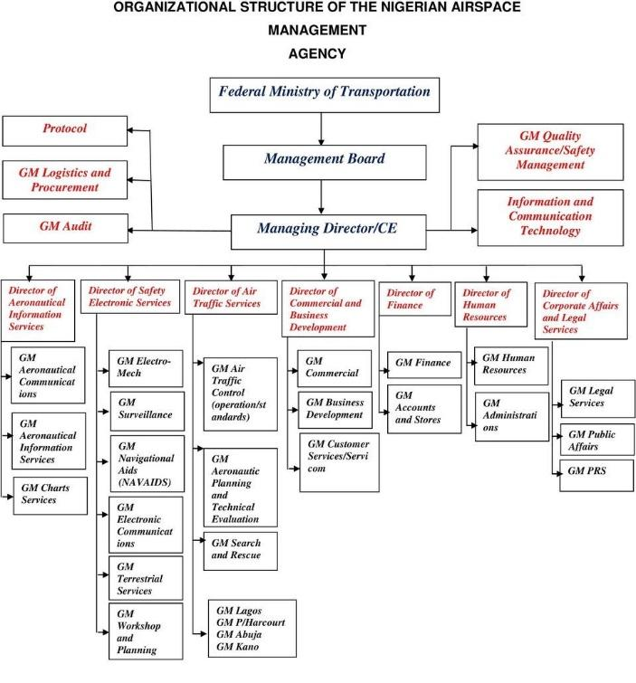

### 2.5 ICT DEPARTMENT IN NIGERIAN AIRSPACE MANAGEMENT AGENCY

The ICT Department in the organization is responsible for maintenance and support of all computers and network hardware and software within the organization. It is also responsible for unified communications and integration of telecommunication (telephone lines and wireless signals) and computers, as well as necessary enterprise software, middleware, storage and audiovisuals, that enable the staff to access, store, transmit,understand and manipulate information within the organization.

### 2.6 ICT VISION

ICT makes information communications technology work for air safety

### 2.7 ICT MISSION

To provide leadership and guidance, service and support, education and technical expertise required to establish and maintain best in class information communication technology systems for the agency.

In accordance with the vision, mission, values and goals of the Nigerian Airspace Management Agency (NAMA)

The ICT Department is headed by the GM(General Manager) ICT in person of Mrs S.A. Onusi.

### 2.8 VARIOUS ICT DEPARTMENT AT NIGERIAN AIRSPACE MANAGEMENT AGENCY

The ICT has various units in which it uses to carry out it’s day to day activities. Each unit has it’s own objective and functions. They include;

● BOS (Business Operations Service)

● BIS (Business Intelligence System)

● ITSM (Information Technology Service Management)

● NETCOMMS (Network Communications)

● REPROGRAPHICS

1. ● BOS (Business Operations Service): This arm of the department is involved in resolving challenges that are related to the hardware and software components of the computer systems used within the agency. The unit also handles procurement and installation of new computer systems and preventive maintenance of the computer systems. The unit is headed by Mr. Femi Opeyori.
2. ● BIS (Business Intelligence Systems): This is the arm of the department that deals with the organization software. This unit oversees the proper functioning of all the organization software (updates, installation e.t.c). it is headed by Mr Patrick.
3. ● ITSM (Information Technology Service Management): This is the arm of the department that oversees and supervises the activities associated with proper service delivery to the staffs. This branch of the department oversees the activities carried out at the help desk and help relay the message to the appropriate unit for further assistance. This unit is headed by Mr Achinivu Nkem.
4. ● NETCOMMS (Network Communications): This branch of the department is in charge of all network related issues within the organization. This unit is headed by Mr E.A. Adeniran.
5. ● Reprographics: This arm of the department is responsible for the printer related issues. This unit focuses mainly on sharp printers due to the act that any other printer within the organization is a network printer and they are usually channeled to NETCOMMS. This unit is headed by Mrs Rammat.

### 2.9 THE HELP DESK

Help Desk Structure and Responsibilities**:**

The Help Desk functions as the front-line responder for any ICT-related issues within the organization. It acts as the communication bridge between employees and the specialized ICT units at NAMA, which include:

* **BOS (Business Operations Service):** Handles operational business software and ensures the smooth functioning of NAMA's critical business applications.
* **BIS (Business Intelligence System):** Focuses on data management and reporting, providing insights for decision-making.
* **ITSM (Information Technology Service Management):** Manages IT service delivery, ensuring that technology services align with organizational needs.
* **NETCOMMS (Network Communications):** Responsible for managing NAMA’s internal and external networks, ensuring stable and secure communication.
* **REPROGRAPHICS:** Provides document reproduction and printing services.

Figure helpdesk interface 1

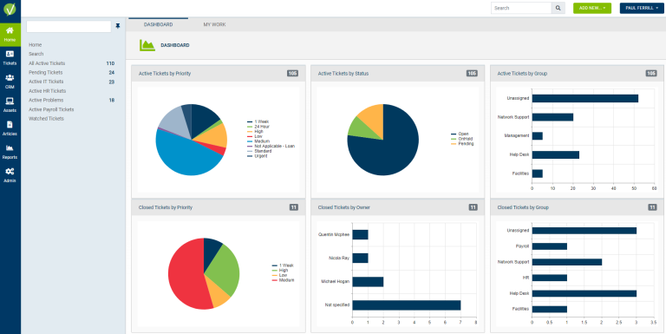

**Key Functions of the Help Desk:**

**1. Ticket Management and Issue Tracking:**

The help desk is responsible for managing incoming help desk tickets, which employees use to report their technical issues. Interns and staff are tasked with:

* **Logging and Categorizing Tickets:** Receiving and categorizing tickets based on the type of issue, such as hardware, software, or network problems.
* **Prioritizing Issues:** Urgent matters, such as network outages or security concerns, are prioritized for immediate attention, while less critical issues like password resets are handled accordingly.
* **Tracking and Escalating Issues:** The help desk tracks each ticket from submission to resolution, ensuring timely updates. If an issue is beyond the expertise of the help desk, it is escalated to the relevant ICT unit (e.g., NETCOMMS for network issues, BOS for business software problems).

**Outcome:**  
This structured ticket management ensures that no issue goes unaddressed and enables the ICT team to deliver fast and efficient responses.

**2. Hardware Support:**

Interns and help desk staff handle a variety of basic hardware-related issues, ensuring that NAMA’s physical equipment is functioning correctly:

* **Peripheral Replacements:** Swapping out malfunctioning keyboards, mice, and monitors for employees.
* **Printer and Scanner Troubleshooting:** Addressing common printer issues such as paper jams, driver installation problems, and connection errors.
* **Workstation Setup:** Assisting in the setup of new workstations, including hardware connections, monitor configurations, and peripheral installations.

**Outcome:**  
This work ensures that employees face minimal disruption in their daily tasks due to hardware failures, improving overall productivity.

**3. Software Support:**

The help desk team assists with troubleshooting and resolving software-related issues, including:

* **Software Installation and Updates:** Installing standard software packages such as Microsoft Office, email clients, and company-specific applications.
* **Application Support:** Resolving application crashes, login issues, and helping users configure email accounts.
* **Password Resets:** Handling forgotten password issues and assisting employees in resetting their login credentials.

**Outcome:**  
This proactive software support ensures that employees have the tools they need to perform their duties effectively, with minimal software-related downtime.

**4. Network Troubleshooting:**

The help desk provides first-line support for network issues, including:

* **Basic Connectivity Troubleshooting:** Diagnosing and resolving local network connection problems, ensuring that employees can access the internet and internal resources.
* **Network Printer Configuration:** Assisting in setting up and maintaining network printers for use across various departments.
* **VPN Setup and Maintenance:** Supporting remote users by configuring VPN access and resolving connectivity issues related to secure remote access.

**Outcome:**  
Network issues are often critical to daily operations, and resolving them promptly ensures that communication and operational workflows remain uninterrupted.

**5. Security and Access Control:**

The help desk also supports basic security measures to protect NAMA’s ICT infrastructure, including:

* **User Account Management:** Creating new user accounts, managing access levels, and deactivating accounts for departing employees.
* **Two-Factor Authentication (2FA):** Assisting employees in setting up 2FA to secure their accounts.
* **Password Policy Enforcement:** Ensuring that employees adhere to NAMA’s security policies by enforcing regular password changes and ensuring passwords meet security standards.

**Outcome:**  
By handling these critical security tasks, the help desk ensures that NAMA’s data remains protected from unauthorized access.

**6. Documentation and Reporting:**

Interns working at the help desk are also tasked with maintaining detailed documentation of all issues reported, which serves multiple purposes:

* **Knowledge Base Creation:** Documenting solutions for frequently occurring issues to create a reference for future help desk members.
* **Reporting:** Compiling daily and weekly reports on the types of issues encountered and resolved, allowing for the identification of trends or recurring problems.

Figure 3 helpdesk interfacee 2

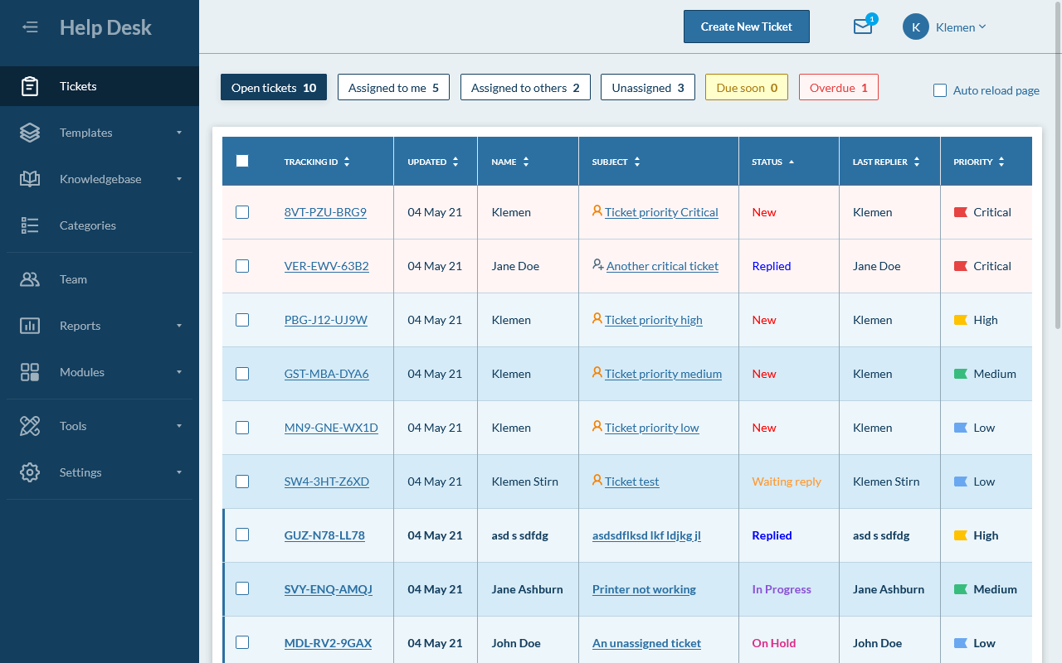

# CHAPTER 3

# **3.0 DESCRIPTION OF WORK DONE**

Most of the departments in Nigerian Airspace Management Agency rely on information and this information can be passed on more reliably and faster through the use of computer systems and other computer accessories like the internet, intranet etc. Thus, there is the need to have a department or a section within the organization that will see to the procurement, distribution, installation, and overall maintenance of these computer systems and their related accessories. This is where the ICT department of NAMA comes into play. The ICT department is located directly under the Managing Director (MD) and is headed by the ICT Manager.

Here are:

### 3.1.2 Network Communications (Netcomms)

The NETCOMMS unit manages the agency’s internal and external communication networks, ensuring stable and secure connectivity for operations. This concerns the local intranet and internet connections. It also manages the connections between the Agency's headquarters, regional office at all local and international airportsin Nigeria.

**Tasks and Responsibilities:**

* Assisted in troubleshooting network-related issues such as connectivity problems and IP address conflicts.
* Helped monitor network traffic to ensure optimal bandwidth usage and prevent network overloads.
* Participated in configuring routers, switches, and firewalls under the supervision of senior network engineers.
* Worked on setting up and maintaining secure connections, including configuring VPNs for remote access.
* Assist in monitoring server performance using network tools
* Check for and resolve IP address conflicts in the network
* Set up basic network file shares
* Help monitor bandwidth usage and network traffic
* Assist in performing scheduled backups of critical data

**Key Contributions:**

* Improved the stability of network connections by identifying and troubleshooting minor network configuration issues.
* Contributed to enhancing the internal communication network by assisting with updates to network infrastructure.

3.1.3 Business Operations Support (BOS)

The BOS unit is responsible for ensuring the smooth operation of business technology services, including managing applications critical to the agency’s workflow, the BOS department handles procurement and installation of new computer systems, repair of existing computer systems and preventive maintenance of the computer systems.

**Tasks and Responsibilities:**

* Assisted in the setup and configuration of business software systems.
* Provided support for daily operations, such as ensuring business-critical applications (e.g., payroll, inventory) were functioning optimally.
* Worked on troubleshooting and resolving application errors reported by staff, escalating issues to senior team members when needed.
* Documented recurring issues and worked on drafting guides for resolving common user errors.
* Diagnose and replace failing hard drives
* Assist in hardware upgrades (RAM, SSD installations)
* Troubleshoot and replace faulty power supplies
* Test and configure new hardware peripherals (external drives, projectors, etc.)
* Assist in setting up and troubleshooting docking stations
* Configure and troubleshoot VPN client software
* Perform basic data recovery using software tools (e.g., Recuva)
* Run antivirus and anti-malware scans on infected machines

**Key Contributions:**

* Improved response times for resolving software issues by documenting common error resolutions on the helpdesk system.
* Assisted in user training sessions to help staff better understand the software tools.

### 3.1.4 Business Intelligence System (BIS)

The BIS unit focuses on managing data and creating actionable insights to support decision-making in NAMA.

**Tasks and Responsibilities:**

* Assisted in gathering and organizing data for reporting purposes, which contributed to analysis for airspace operations.
* Supported the team in generating reports using BI tools such as Microsoft Power BI, ensuring accuracy in data representation.
* Helped with database management, including backup tasks and ensuring data integrity for critical reports.
* Participated in brainstorming sessions on how to improve data collection processes for enhanced reporting efficiency.

**Key Contributions:**

* Played a part in improving report generation time by automating certain data collection processes.
* Assisted in developing data visualizations that provided clearer insights for management.

The BOS and NETCOMS arms of the department are situated in the central workshop with two supervisors overseeing the activities going on there. This is where the repair, maintenance and general fixing of computers, computer resources and networking.

Here the IT students, under the supervision of two IT personnel, assist and resolve problems that are brought in from other departments. When this is done, the status of the problem (either it is resolved or work is still in progress) is logged down both at the helpdesk and in the workshop. Logging down these cases is done for record purposes. This will enable the ICT department to know which problems are predominant in the organization, which users need to go for IT courses for further enlightenment and in general, try to find solutions to problems at hand. Then the computers and/or its peripherals are taken back to their various users. Also, there are cases Then the computers and/or its peripherals are taken back to their various users.

Also, there are cases where these problems do not need to be brought to the workshop and can be resolved in the various offices in which the complaints came from.

**3.2 EXPERIENCE ACQUIRED**

* I was shown how to format a hard disk, installing and configuring operating systems on a formatted system, downloading and installation of necessary drivers and installation of other application software. I was placed under the supervision of Mr Obawole Taofik B. In the following month, I was assigned to the NETCOM arm of ICT department under the supervision of Mr. Emmanuel Adeniran, where I learnt different networking topologies, worked with different networking devices like the hubs, switches, routers and network printers. I got to know how to solve some networking problems both on the intranet and the internet. I was also able to identify various components used to develop network connections, like the modem and network cards.

Among the other things I learnt were how to terminate network (twisted pair) cables and how to connect computers to the local area network. How to troubleshoot various networking problems, like when a user has connectivity problem, inability to log on to his or her user account etc. Configuration of wireless connection on laptops and desktops. Configuration of switches, hubs and routers. How to lay network cables. How to install network printers and add it to a system. Adding systems to a domain and creating a network between computers and other peripherals.

* I also learnt about different types of server such as proxy, database, and file servers. In addition to this, I understood and practiced how to configure and connects multiple computer systems to access points, in which in turn connects to the server base for connectivity. Learnt how ethernet cables, switches and routers are used for internet connectivity. Understood how Nama uses proxy servers for added privacy over a private network.
* Learnt in depth on why and how to troubleshoot computer hardware and its peripherals, troubleshooting is carried out to identify a faulty component or components in a system, this is to ensure that a healthy component is not mistaken for issues. This saves, time, effort and technical skill. Troubleshooting was carried out severally and effectively on different systems resulting in different repairs. For example, a system that keeps turning on but no display was brought for repair at the office. On initial troubleshooting, we found that there was indication of power supply so the power control unit was functioning properly, there was no dusty fans on opening the system so it couldn’t be the cooling fans either. From prior experience, the ram of a computer system has to be in good condition or else there will be no memory allocated for boot up, upon this knowledge, the ram was checked, cleaned with little alcohol and then reseeded properly and this fixed the problem of the system.
* Learnt in depth on how the use of computer drivers. Computer drivers are a sort of intermediary between computer hardware and the operating system, this means all hardware come with a driver. A driver depicts how a computer hardware will communicate with the operating system. It contains a set of files that are important for the functioning of the hardware. For example, I once stumbled on a printer that wasn’t printing eve though it was connected to the computer system properly during my internship, I troubleshot the printer but there was no faulty components with the printer neither the computer, we found out the drivers were outdated and was causing the printer not to function.
* Learnt about the functioning of a cmos battery, this component located on the motherboard is responsible for the bios start of a computer system, if the cmos battery runs out of power, fails or is not connected properly, It will lead to incorrect time and date because this information is kept tracked by the cmos battery. This experience was acquired when I came across a system that ad incorrect date and time and didn’t allow users to set the correct date and time. I was taught about the cmos battery with this opportunity and how it is directly related to the bios status of a computer.

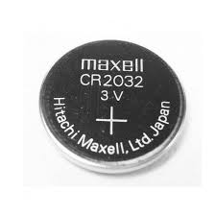

* Learnt how to install new operating system on a computer. The need to do this can be for numerous reasons, such as; unfriendly interface of previous operating system, infected operating system, slow computer system, etc Specifically learnt how to install windows 11 on outdated computers.
* Learnt on how to configure IP address for window using TCP

### I was assigned to the BOS ,BIS ,Netcomms and HELPDESK arm of the department, depending on my scheduled shift for the day, where I was taught on the identification of various component of computer hardware, e.g. hard disk, floppy diskette, random access memory (RAM), cmos battery, VGAs, power supply unit, removing and replacing of these hardware components, installation of various software and operating systems where necessary, how to connect various devices (printers and scanners) and other computer peripherals.

### 

### 3.2.1 Work done at the helpdesk

As an intern working in the help desk section of the ICT Department at NAMA, I was involved in first-line IT support for the entire organization. The help desk serves as the primary point of contact for employees reporting technical issues, ranging from hardware malfunctions to software troubleshooting. My role was to manage, resolve, or escalate technical issues to ensure smooth daily operations for the staff. Below is a detailed account of the tasks and contributions made during my internship at the help desk.

**Daily Operations and Support:**

**1. Ticket Management:**

* **Logging and Categorizing Tickets:** I was responsible for receiving, logging, and categorizing incoming IT help desk tickets from various departments. This involved understanding the issue at hand and determining whether it was hardware, software, or network-related.
* **Ticket Prioritization:** I prioritized tickets based on urgency, ensuring that mission-critical issues (such as network failures or security concerns) were addressed promptly.
* **Issue Tracking and Resolution:** I continuously monitored open tickets, keeping track of progress and ensuring that issues were resolved in a timely manner. For tickets I couldn’t resolve directly, I escalated them to specialized units like NETCOMMS or ITSM.

**2. Hardware Troubleshooting and Support:**

* **Basic Hardware Fixes:** I handled minor hardware issues, including the replacement of faulty peripherals (mice, keyboards), repairing non-responsive printers, and diagnosing issues with workstations.
* **Workstation Setup:** I helped in setting up and configuring new workstations for employees, ensuring that hardware was correctly connected and software was pre-installed and ready for use.
* **Printer and Scanner Support:** Ensured printers, scanners, and photocopiers were functioning correctly across departments, resolving issues like paper jams, driver errors, and toner replacements.

**Key Contribution:**

* Reduced downtime for staff by promptly addressing and resolving common hardware issues. Assisted in setting up new devices for incoming staff or replacing defective ones efficiently.

**3. Software Installation and Support:**

* **Software Installation:** I installed and updated standard company software, including productivity tools like Microsoft Office, PDF readers, and company-specific applications.
* **Software Troubleshooting:** Assisted users in troubleshooting software-related issues such as application crashes, login problems, and email configuration errors.
* **Password Resets:** A large part of my role involved managing password resets for users who were locked out of their accounts or forgot their login details.

**Key Contribution:**

* Improved the overall efficiency of software installations by creating a streamlined process for software deployment, ensuring users received necessary tools faster.

**4. Network Support:**

* **Network Connectivity Troubleshooting:** I provided basic support for network connectivity issues, helping users resolve Wi-Fi connectivity problems and ensuring proper LAN connections.
* **Network Printer Configuration:** Assisted in configuring network printers, ensuring they were accessible by all departments, and troubleshooting issues related to network printing.
* **VPN Setup and Support:** Supported remote employees by helping configure VPN connections and resolving any connectivity issues they encountered.

**Key Contribution:**

* Ensured a stable network environment by quickly diagnosing and fixing minor network issues, reducing disruptions to the overall workflow.

**5. Security and Access Management:**

* **User Account Management:** I was involved in creating new user accounts for new employees and ensuring they had the proper access permissions to necessary files and folders.
* **Basic Security Measures:** Assisted users in setting up two-factor authentication (2FA) and educated them on basic security protocols to help safeguard company data.
* **Password Policy Enforcement:** Ensured that users adhered to password policies by guiding them through password resets and encouraging secure password practices.

**Key Contribution:**

* Helped maintain the security and integrity of the organization’s systems by ensuring proper user access and compliance with security protocols.

**6. Documentation and Reporting:**

* **Documentation of Resolved Issues:** I documented the solutions for frequently occurring issues, creating a knowledge base that helped future help desk team members quickly resolve similar problems.
* **Help Desk Reports:** Compiled daily and weekly reports on the number of tickets processed, types of issues resolved, and any outstanding problems that required follow-up.

**Key Contribution:**

* Developed an internal knowledge base that reduced repetitive queries and enabled faster resolutions. The reports helped identify recurring issues, allowing the team to focus on preventing them in the future.

**Collaboration with ICT Units:**

Throughout my internship, I closely collaborated with other ICT units, such as NETCOMMS, ITSM, and BOS, for escalated issues that required more advanced solutions.

* **NETCOMMS:** Worked with the network team to address recurring connectivity and IP address conflict issues. Helped test network stability after configurations or updates were made.
* **ITSM:** Partnered with the ITSM unit for service delivery improvements, learning how to implement better tracking of help desk tickets and service levels.
* **BOS:** Occasionally assisted the BOS team in resolving software-related issues that affected business operations, ensuring systems like payroll and scheduling software were functioning optimally.

3.2.2 Some of the computer components that I familiarized myself with

### The Motherboard

this is a thin flat piece of circuit board (usually of green or gold color). Everything in the Computer connects, directly or indirectly, to the motherboard. It contains a number of special sockets that accepts various components of the computer. he motherboard is the main circuit board in a computer system that serves as the foundation for all other components. It houses the CPU (central processing unit), RAM (random access memory), and other essential hardware, ensuring they can communicate with each other. The motherboard also provides connectors for storage devices (like SSDs and hard drives), graphics cards, and peripherals (such as keyboards, mice, and printers).

In addition to connecting hardware components, the motherboard distributes power from the power supply to various parts of the system. It contains the BIOS firmware, which is responsible for initializing hardware during the boot process and managing system default settings. Essentially, the motherboard acts as the backbone of the computer, enabling different components to work together to perform tasks.

**Components on a motherboard.**

### Read Only Memory (RAM)

The random access memory stores programs and data currently being used by the CPU. It is measured in bytes, which is measured in megabytes where you have millions of bytes of RAM. The average PC usually has between 32 megabyte/128 megabyte to 1 gigabyte of RAM (modern PCs may have several megabytes). The RAM has a socket that allows it to be placed on the motherboard.

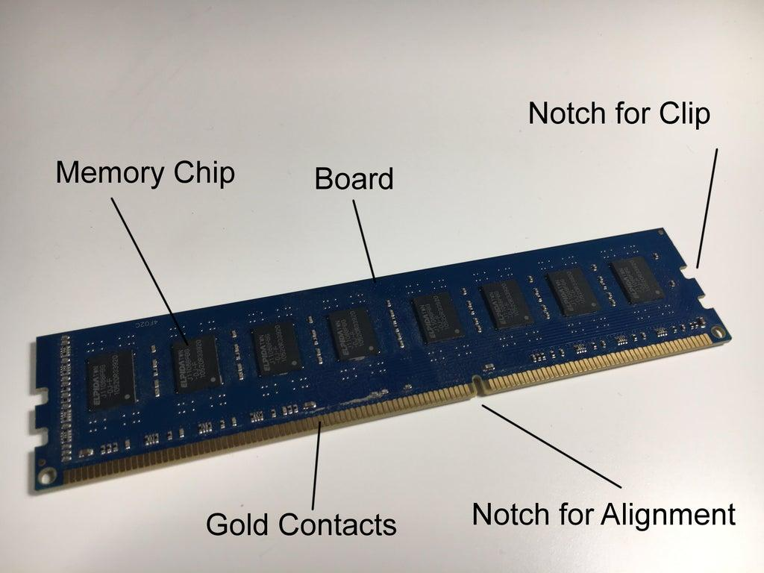

A picture of a typical PC RAM

Hard drive**:** Hard drives stores programs that are not currently being used by the CPU. Like the RAM, hard drive capacity is measured in megabytes. A typical PC hard drive stores much more data than the RAM and thus can range from 500 megabytes (in very old systems) to more than 75 to 100 gigabyte. Like every other component of the PC, the hard drive has connectors called the EIDE cables. They also have power cables.

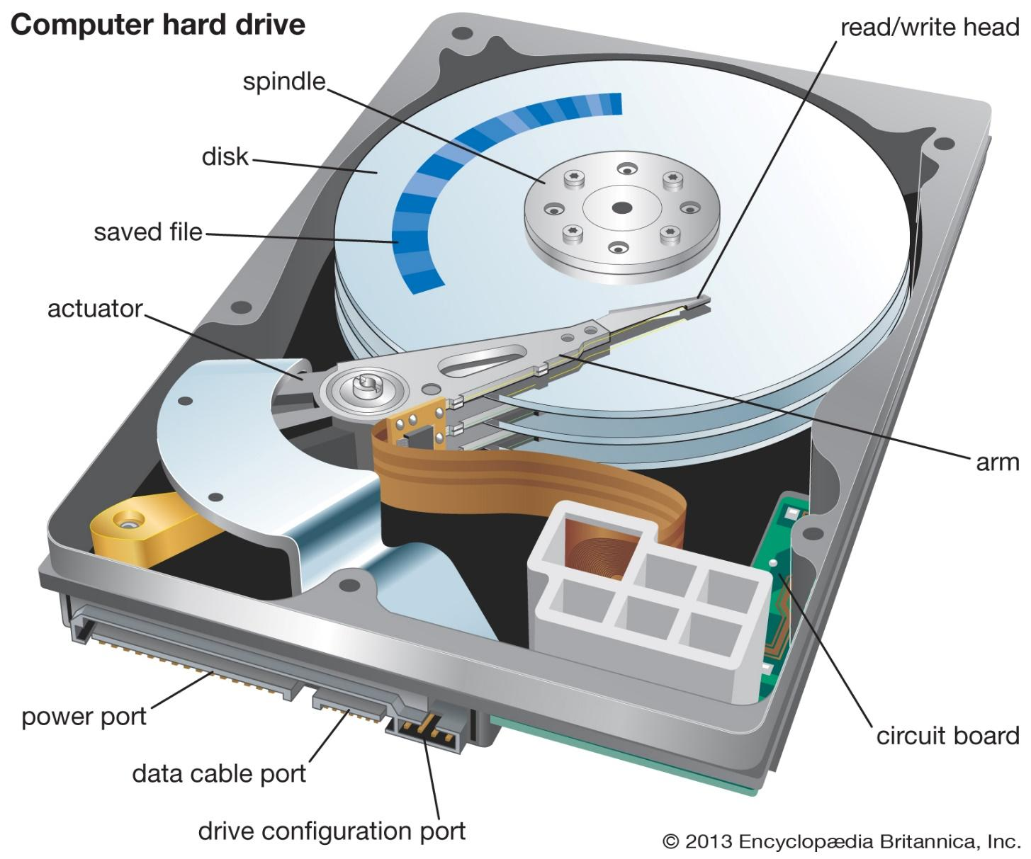 Fig 1.2

Figure 4 A typical diagram of a computer HDD hard drive

A typical diagram of a computer HDD hard drive

* **DVD/CD ROM Drive**: The DVD/CD ROM drives enables access to DVD and CD ROMs. Some PC s come with recordable and or rewritable CD and DVD. They also need power supply via the power cable.
* **Connectors:** These connectors (often called ports) allows for connection of other components of the computer. We have the DB (printers, monitor), DIN (keyboard, mouse), Centronics (printer),

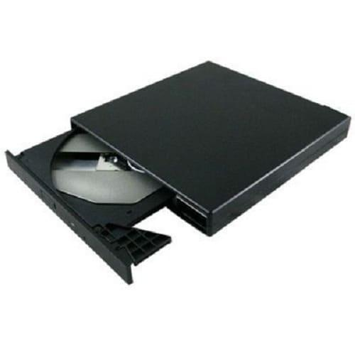

RJ (network interface card, modem), BNC (network interface cards), Audio (speakers, headphones) and USB (keyboards, mouse, printers, disk drives e.t.SSc) connectors, each with its own type of device that it connects to the computer.

Figure 5 different types of ethernet connectors

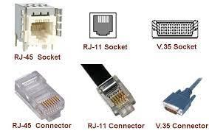

* **Cooling system:** Cooling system consists of two or more fans. One fan for the system (CPU), and one for the processor. The CPU will operate more reliably and will have a longer lifespan if the cooling system is working properly.
* **Power supply:** The power supply distributes power to the motherboard and other components in the CPU. The PSU distributes power to key components, including the motherboard, CPU, RAM, hard drives, and expansion cards. It also regulates voltage to ensure stable and safe operation, protecting components from power surges or irregularities. A reliable PSU is critical for the overall stability and performance of a computer.
* **A hub**: it is a physical layer networking device which is used to connect multiple devices in a network. They are generally used to connect computers in a LAN. A hub has many ports in it. A computer which intends to be connected to the network is plugged in to one of these ports

A hub is a device that acts as a central connection point for computers on a network shown in fig 1.5 below. Every computer plugs into the hub.

Figure 6A Hub connection

switch: Such as the one shown in Fig 1.6 below, performs all of the same basic tasks as a hub, but the switch uses a set of internal logic circuits to establish a dedicated, logical path between the two PCs. This provides for more efficient data transfer without collision which occurs in the hub two PCs.

This provides for more efficient data transfer without collisions which occurs in the hub. They both have ports for RJ-45 connectors which computers use to connect to the network.

Figure 7 vlan connection

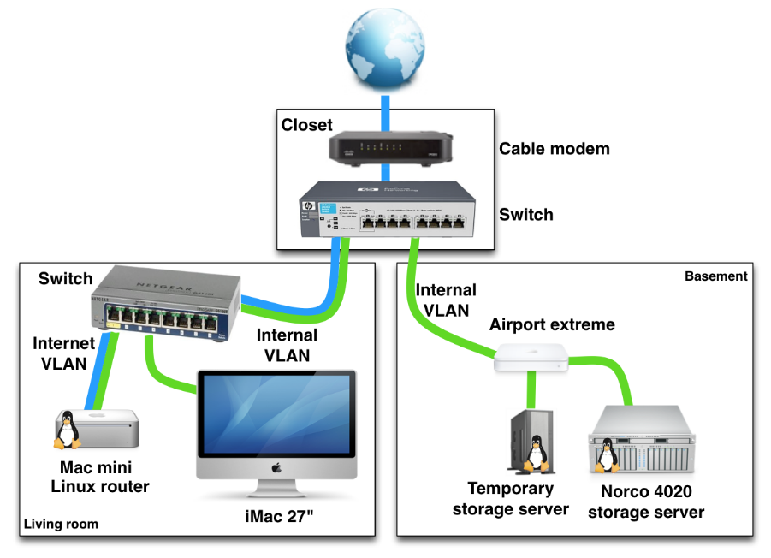

Network Adapter: The Network Adapter is the source through which the computer connects to the network as well as all other computers on the network. A pictorial representation is shown below:

Figure 8 anetwork adaptor

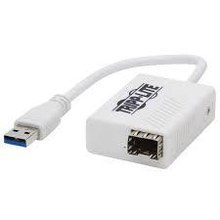

A network (Ethernet) cable with an RJ-45 connector terminated at the end.

The Ethernet cable: are network cables containing eight wires with different colors. These wires

are arranged and terminated according to the type of connection needed. We have the straight ended terminated cable, for connecting devices that are dissimilar (e.g computer to hub/switch, switch to hub etc). We also have the cross ended terminated cable, for connecting devices that are the same (e,g computer to computer, switch to switch, hub to hub etc). The colors of the wires are green, orange, blue and brown. Four of these wires have these colors in full while the remaining four have the colors but with stripes of white along it. For straight ended cables, the color code is: White/Orange (i.e. orange color striped with white) followed by full Orange, white/green-blue, white/blue-green, white/brown-brown.

 For cross-ended cables, we have: White/green-green, white/orange-blue, white/blue-orange, white/brown-brown. All these wires are arranged in line and inserted into the RJ-45 connector which is then held in place (crimped) by a crimping device. The diagram is shown below:

Figure 9 a naked ethernet cable

### 3.3 Role of student during SIWES

The functions of the IT students are the following:

1. Register for SIWES and submit at the point of registration, their bank account details. (i.e., Bank name, Account name, Account number (NUBAN), and Bank sort code;)
2. To attend the institution’s SIWES Orientation Program before going on attachment;
3. To be obedient to constituted authorities and adhere strictly to all rules and regulations of the organization where a student is attached;
4. To be regular and punctual at places of attachment;
5. Avoid change of place of attachment except in special circumstances;
6. Complete Students Commencement Attachment Form (SCAF) and get it endorsed and stamped by the employer and submit it to the nearest ITF Area office;
7. Record all your training activities and other assignments in logbooks and complete ITF Form-8 to ensure proper assessment
8. Be diligent, and honest and take pride in the protection of employers’ property throughout the attachment period.

### 3.4 OBJECTIVES OF THE REPORT

The objectives of the SIWES report are;

* To provide an in-depth justification of the work completed throughout my four-month industrial training.
* To meet the requirements for a national computer science diploma.
* To advance the body of information and the writer's knowledge of a related or identical job.

### 3.4.1 THE LOGBOOK

The institution gave the student a logbook in which to record all daily activities that took place during the attachment period. During supervision, the ITF and supervisors from the industry and the institution verified and approved the information.

### 3.4.2 Participation of student during SIWES

I was an IT intern at Nigerian Airspace Management Agency and took part in the following activities:

● How to build and connect a Local Area Network (LAN) and connect it to a system.

● The installation of a printer on a system.

● How to update an operating system and also how to format or load a new operating system on the system.

● How to change the Complementary Metal-Oxide-Semiconductor on a system.

● The installation of a new version of Microsoft Office on a system if the current version has run out of time or is already corrupt.

● Installation of AX on a system from the company server.

● How to troubleshoot a system.

● How to remove a virus from a client system and how to set up fresh antivirus software on the client system.

● How to maintain and repair a system's Random Access Memory (RAM).

# CHAPTER 4

## CHALLENGES AND RECOMMENDATION

## 4.1 CHALLENGES

The following are challenges I encountered in participating in the SIWES training program:

1. Obtaining a placement for the Industrial Training was difficult as most companies did not take students on 6 months IT.
2. High cost of transportation to and from the company head office.
3. Payment fee required to get industrial training from companies offering to take IT students.

## 4.2 RECOMMENDATIONS

***SIWES*** in conjunction with federal Government should enact laws which will compel private sectors to take students for Industrial training.

***SIWES*** in conjunction with the federal government should create industrial training slots for students in public companies and post IT students for training on time.

***SIWES*** in conjunction with the federal government should support private companies in relieving the financial stress off IT students.

University of the IT students should collaborate with companies to take incoming IT students to relieve the stress of IT students.

University of IT students should recommend companies with deep learning and good history of trained IT student to the student for easy access and good training.

## 4.3 OBSERVATIONS AND CONTRIBUTIONS

During my stay at NIIT, I observed that the company aimed at ensuring that their interns have as much hands-on experience as possible. As an intern at NIIT, I faced real work situations and challenges and I had to learn how to deal with them accordingly.

The environment was very conducive; it enabled the flow of creativity. The Classes was a place where everyone could easily share their ideas, be themselves and be productive. I had the opportunity to contribute during activities and I was able to immerse myself in the Lectures.

## 4.4 RELEVANCE OF EXPERIENCE/KNOWLEDGE GAINED

One of the Important skills I gained during my Industrial Training at NIIT is the skill of critical thinking and problem solving, as an engineer those skills are important and I was able to gain the skill during my IT training.

My Industrial Training at NIIT was a time of work and dedication. I gained greatly in the area of knowledge and skills acquisition. The training provided me with the opportunity to put all the knowledge I had gained in school into practice. It also broadened my mind about the complexities of my course and taught me parts of it that I had not yet been exposed to. I learnt how to appreciate the role my course plays in the life of people and what impact it has on society at large.

This training gave me the ability to work with professionals in the enterprise field and gain hands-on experience.

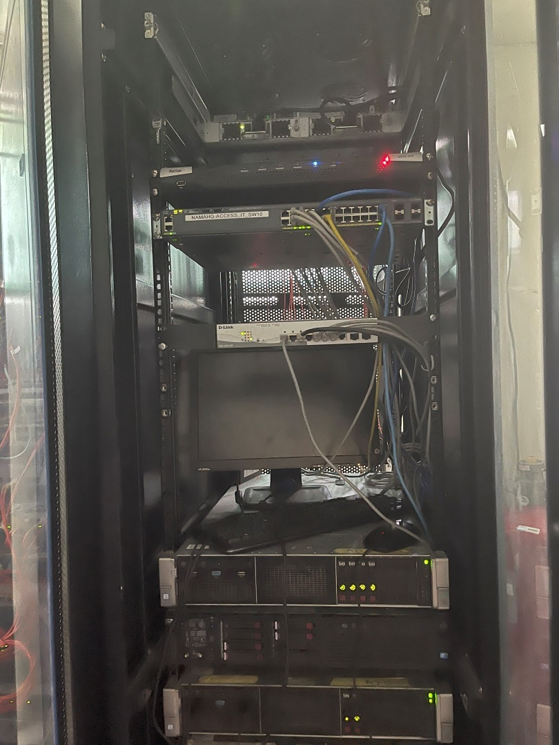

Figure 10 server

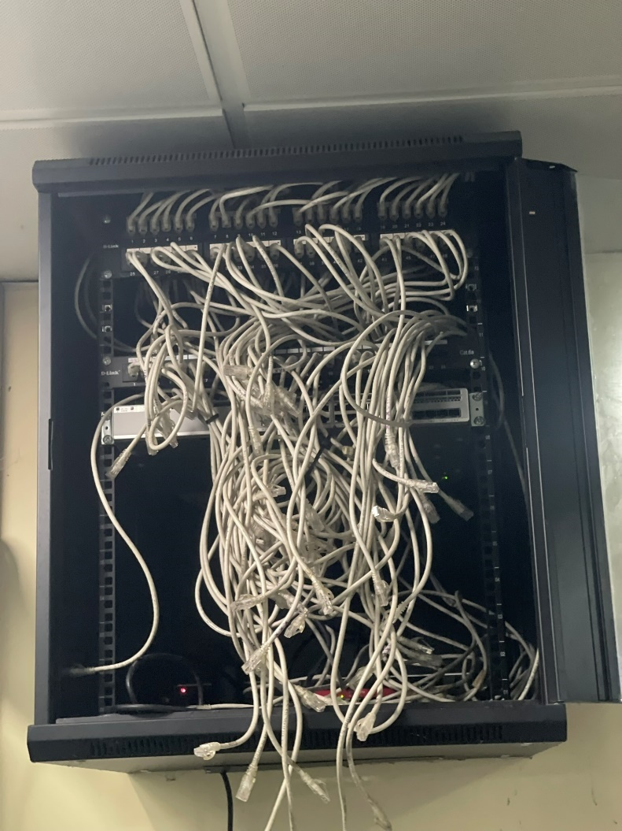

Figure 11 server extension

# CHAPTER 5

## CONCLUSION

## 5.0 CONCLUSION

My Industrial Training at NAMA was a time of hard work and dedication. I gained tremendously in the area of knowledge and skills acquisition.

The training provided me with the opportunity to put all the knowledge I had gained in school into practice. It also expanded my mind about the broadness of my course and taught me parts of it that I had not yet been exposed to also giving me knowledge and preparing for the future after school.

I learnt how to appreciate the role my course plays in the life of people and what impact it has on society at large.

This training gave me the ability to work with professionals and also learn to work with other employees in the tech world. It enabled me to gain hands-on experience that I would not have had the chance to learn without the Industrial Training Programme.

This programme has helped to mold and build me more as a person and an engineer and I believe that is an important aspect in choosing where to work.

### 5.1 recommendation

I've made sure to remember the following key recommendations from the comprehensive report on help desk operations at NAMA's ICT department that can further enhance efficiency and service delivery:

1. **Automated Ticketing System:** Implement a more sophisticated ticketing system that automates ticket prioritization, ensuring critical issues are addressed promptly without manual intervention.
2. **Expand the Knowledge Base:** Create a more extensive internal knowledge base with detailed documentation and step-by-step solutions for common problems. This will streamline the troubleshooting process for future help desk teams and interns.
3. **Ongoing Staff Training:** Regularly schedule training sessions for help desk staff and interns to stay updated on new tools, software, and systems. This will ensure the team is equipped to handle a wider range of issues effectively.
4. **Collaboration Between ICT Units:** Continue fostering strong collaboration between the help desk and other ICT units (BOS, NETCOMMS, ITSM, and REPROGRAPHICS) to ensure escalated issues are resolved efficiently by the appropriate experts.

# REFERENCES

1. [www.docplayer.net](http://www.docplayer.net)
2. zachcomputer.net
3. www.google.com
4. [www.partitionwizard.com](http://www.partitionwizard.com)
5. Nama ICT department module
6. [www.@nama.gov.ng](http://www.@nama.gov.ng)
7. [www.afribary.com](http://www.afribary.com)
8. [www.siwesbiginner.com](http://www.siwesbiginner.com)
9. [www.legit.com](http://www.legit.com)